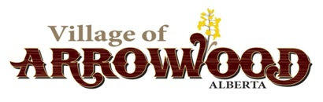
Village of Arrowwood
Administrative Policy 4.1 Municipal Policy Handbook

Office Hours of Operation

Date Approved by Council: 2023-12-12 Resolution: 2023-12-12
Review Date: December 2026 Related Bylaw: N/A Amendments:

Purpose
This policy has been adopted to provide guidelines for the normal business hours of operation for the Village of Arrowwood Municipal Office.

Guidelines
The Village of Arrowwood Office will be open Tuesday from 10:00 am to 12:00 pm and from 1:00 pm to 4:00 pm.

The Village Office will be closed between 12:00 pm and 1:00 pm for lunch.

The Village Office will be closed during all Holidays as per Personnel Policy 3.7, when vacation time is taken by the CAO, when the CAO is attending training or meetings.

The Village Office will be closed for Christmas Break from December 25 to December 31 of each year. Employees will receive pay for holidays as per Personnel Policy 3.7 during this time. On any day during the office closure, which is not a holiday as per Policy 3.7, employees will be required to utilize Vacation days to receive full pay for this period. If the employee does not have the required Vacation days to cover the office closure days, council may approve additional vacation days.

The public will be notified of any Office closure via public notice posted at the Village Office, Post Office and on the Village of Arrowwood’s Facebook Page.

