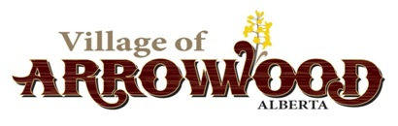
Village of Arrowwood
Legislative Policy 2.4 Municipal Policy Handbook

Policy Manual Review

Date Approved by Council: 2023-12-12 Resolution: 2023-12-12-11

Review Date: December 2026 Related Bylaw: N/A Amendments:

Policy Statement
It is necessary that all approved Village of Arrowwood policies be reviewed and/or amended on a regular basis.

Guidelines
Each approved policy will include a review date upon which the policy will be reviewed by Council at the next Regular Meeting after the review date.

Legislative Policies will be reviewed annually at the Organizational Meeting of Council.

Policies that are reviewed by Council with no amendments do not require a resolution, but a note shall appear in the Minutes listing all policies that were reviewed at that meeting.

Responsibilities
The Chief Administrative Officer is responsible for filing and organizing approved policies and for tracking review dates as well as presenting new and approved policies for review to Council.

Council is responsible for reviewing and/or amending all policies upon presentation of the policy at a meeting of Council.

