A Community
Kiddies
Halloween Party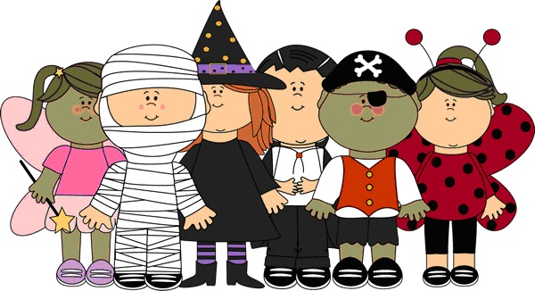
Lodge Hall Basement Monday,
October 31st 2022
4 pm to 7 pm
Come for supper (grill cheese and soup), Games, and Yummy Treats

A Community Service Project by

